MICRO PROJECT REPORT

- Title of Micro Project: Student Result Management System using SQL

- Brief Description:
The Student Result Management System is a database-based project developed using SQL.
It stores student information, subjects, and marks and generates academic results.
It maintains details such as student roll number, name, class, section, contact, subjects, and marks.
The system allows operations like inserting student and subject records, storing marks, calculating total marks, percentage, and grade of each student.
This project demonstrates the use of DDL, DML, joins, aggregate functions, GROUP BY, and CASE statements in SQL to solve a real-life academic result processing system.

- Aim of Micro Project:

- To learn and implement basic and advanced SQL concepts.
- To design a database for efficiently maintaining student result records.
- To perform operations like data insertion, updating, and result calculation.
- To generate reports such as total marks, percentage, grade, and section-wise summary.
- To understand real-world relational database management in educational systems.

- Course Outcome Integrated:

- Understanding of RDBMS concepts and SQL queries.
- Ability to create tables with primary and foreign keys.
- Performing insert, join, and aggregate operations.
- Preparing real-time data reports using SQL.
- Hands-on experience with database design and implementation.

- Actual Procedure Followed:
  - Identified requirements for a student result management system.
  - Designed database schema with three tables:
- Students
- Subjects
- Results
  - Implemented table creation using CREATE TABLE.
  - Inserted sample data using INSERT INTO.
  - Applied JOIN, SUM(), and GROUP BY queries to generate result sheets.
  - Calculated total marks, percentage, and grades using expressions & CASE statement.
  - Tested queries with multiple students and subjects.
  - Generated sorted and section-wise result reports.

- Actual Resources Used:

Sr. No. | Resource/Material | Specifications | Qty | Remarks
1 | Computer / Laptop | 4GB RAM or higher | 1 | For development/testing
2 | Compiler | Turbo C / GCC | 1 | For compiling and testing
3 | Documentation Tool | MS Word | 1 | Report creation

- Practical Skills:
- Designing ER structure and tables in SQL.
- Creating database with primary & foreign key relationships.
- Using INSERT, JOIN, GROUP BY, ORDER BY, and CASE.
- Computing results using aggregate functions.
- Creating meaningful reports from database.

CODE:

CREATE TABLE students (
roll_no NUMBER(10) PRIMARY KEY,
name VARCHAR2(20),
class VARCHAR2(20),
section VARCHAR2(20),
contact VARCHAR2(20)
);

CREATE TABLE subjects (
subject_id NUMBER(10) PRIMARY KEY,
name VARCHAR2(20),
max_marks NUMBER(10)
);

CREATE TABLE results (
result_ID NUMBER(10) PRIMARY KEY,
roll_no NUMBER(10),
subject_id NUMBER(10),
marks_obtained NUMBER(10),
FOREIGN KEY (roll_no) REFERENCES students(roll_no),
FOREIGN KEY (subject_id) REFERENCES subjects(subject_id)
);

//STUDENTS INSERTING VALUE
INSERT INTO students (roll_no, name, class, section, contact)
VALUES (1, 'Saad Kazi', '12th', 'A', '9999999999');

INSERT INTO students (roll_no, name, class, section, contact)
VALUES (2, 'Ali Khan', '12th', 'A', '8888888888');

INSERT INTO students (roll_no, name, class, section, contact)
VALUES (3, 'Sara Patel', '12th', 'B', '7777777777');
\\STUDENTS INSERTING END\\\

//SUBJECT INSERTING VALUES
INSERT INTO subjects (subject_id, name, max_marks)
VALUES (101, 'Mathematics', 100);

INSERT INTO subjects (subject_id, name, max_marks)
VALUES (102, 'Physics', 100);

INSERT INTO subjects (subject_id, name, max_marks)
VALUES (103, 'Chemistry', 100);
\\SUBJECT INSERTING END\\

//RESULT INSERTING START//
INSERT INTO results (result_ID, roll_no, subject_id, marks_obtained)
VALUES (1, 1, 101, 85);

INSERT INTO results (result_ID, roll_no, subject_id, marks_obtained)
VALUES (2, 1, 102, 90);

INSERT INTO results (result_ID, roll_no, subject_id, marks_obtained)
VALUES (3, 1, 103, 78);

INSERT INTO results (result_ID, roll_no, subject_id, marks_obtained)
VALUES (4, 2, 101, 70);

INSERT INTO results (result_ID, roll_no, subject_id, marks_obtained)
VALUES (5, 2, 102, 75);

INSERT INTO results (result_ID, roll_no, subject_id, marks_obtained)
VALUES (6, 2, 103, 80);

INSERT INTO results (result_ID, roll_no, subject_id, marks_obtained)
VALUES (7, 3, 101, 88);

INSERT INTO results (result_ID, roll_no, subject_id, marks_obtained)
VALUES (8, 3, 102, 92);

INSERT INTO results (result_ID, roll_no, subject_id, marks_obtained)
VALUES (9, 3, 103, 85);
\\RESULT INSERTING END\\\

Output:
Students Table:
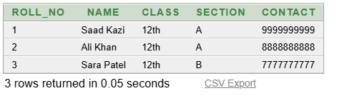

Subjects Table:
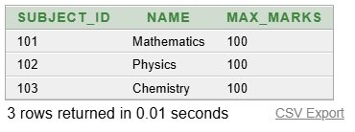
Results Table:
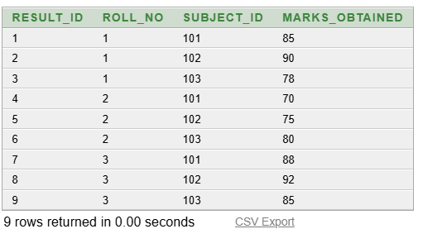

TOATAL MARKS PER STUDENTS

SELECT s.roll_no, s.name, SUM(r.marks_obtained) AS total_marks
FROM students s
JOIN results r ON s.roll_no = r.roll_no
GROUP BY s.roll_no, s.name;

Output:
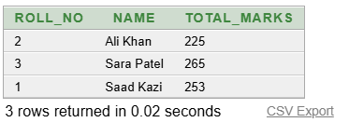

PERCENTAGE PER STUDENTS.

SELECT s.roll_no, s.name,
SUM(r.marks_obtained) AS total_marks,
SUM(sub.max_marks) AS total_max_marks,
(SUM(r.marks_obtained)/SUM(sub.max_marks))*100 AS percentage
FROM students s
JOIN results r ON s.roll_no = r.roll_no
JOIN subjects sub ON r.subject_id = sub.subject_id
GROUP BY s.roll_no, s.name;
Output:
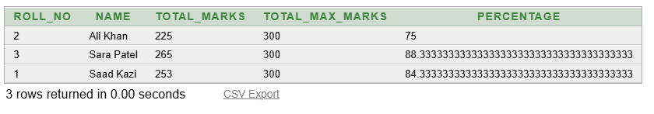

GRADE PER STUDENTS

SELECT s.roll_no, s.name,
(SUM(r.marks_obtained)/SUM(sub.max_marks))*100 AS percentage,
CASE
WHEN (SUM(r.marks_obtained)/SUM(sub.max_marks))*100 >= 90 THEN 'A'
WHEN (SUM(r.marks_obtained)/SUM(sub.max_marks))*100 >= 75 THEN 'B'
WHEN (SUM(r.marks_obtained)/SUM(sub.max_marks))*100 >= 50 THEN 'C'
ELSE 'F'
END AS grade
FROM students s
JOIN results r ON s.roll_no = r.roll_no
JOIN subjects sub ON r.subject_id = sub.subject_id
GROUP BY s.roll_no, s.name;

Output:
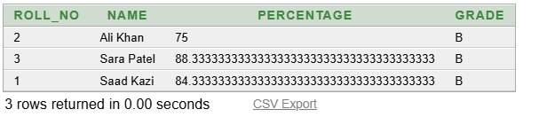

STUDENTS SORTED ACCORDING TOTAL MARKS;

SELECT s.name, SUM(r.marks_obtained) AS total_marks
FROM students s
JOIN results r ON s.roll_no = r.roll_no
GROUP BY s.name
ORDER BY total_marks DESC;

Output:
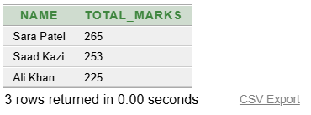
SECTION SPECIFIC REPORT

SELECT s.name, SUM(r.marks_obtained) AS total_marks
FROM students s
JOIN results r ON s.roll_no = r.roll_no
WHERE s.class = '12th' AND s.section = 'A'
GROUP BY s.name
ORDER BY total_marks DESC;

Output:
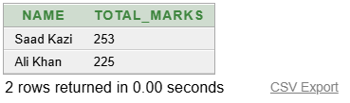

Group Members:

Sr. No. | Name | Roll No.
1 | Mohd saad khan | 24203A0007
2 | Saad sharif kazi | 24203A0013
3 | Vaibhav badade | 24203A0014

Name of Programme: Computer Engineering
Semester: 3
Course Title: Data Base Management System
Code: 313302
Title of the Micro Project: Student Result Management System using SQL
Course Outcomes Achieved:

- Learned to apply OOP concepts such as classes, objects, constructors, and friend functions.
- Strengthened problem-solving skills through modular and menu-driven programming.
- Improved understanding of OOP concepts in practical real-life applications.

Micro Project Evaluation Sheet
Comments/Suggestions about team work/leadership/inter-personal communication (if any)

----------------------------------------------------------------------------------------------------------------------------

--------------------------------------------------------------------------------------------------------------------

Any other Comments:
-------------------------------------------------------------------------------------------------------------------------

-------------------------------------------------------------------------------------------------------------------------

